Credit Card Approval Prediction System

Table of Contents
- Introduction
- Ideation Phase
- Requirement Analysis
- Project Design
- Project Planning & Scheduling
- Functional and Performance Testing
- Results
- Advantages & Disadvantages
- Conclusion
- Future Scope
- Appendix

1. INTRODUCTION
In today's digital banking environment, banks and financial institutions receive thousands of credit card applications every day. Evaluating each application manually is a time-consuming process that requires significant effort from credit analysts. Manual verification is also prone to human errors and inconsistencies, particularly when processing a large number of applications. Credit approval decisions depend on several factors, including annual income, employment status, education level, credit history, existing loans, repayment behavior, and other financial indicators. Therefore, there is a growing need for an automated system that can support faster, more accurate, and consistent decision-making.
Machine Learning (ML), a branch of Artificial Intelligence (AI), has become an effective solution for predictive decision-making in the banking and financial sector. By analyzing historical applicant data, machine learning algorithms can identify patterns and accurately predict whether a new credit card application is likely to be approved or rejected. Such intelligent systems help reduce processing time, improve operational efficiency, and minimize the risk of incorrect decisions.
The Credit Card Approval Prediction System is a machine learning-based web application developed to automate the credit card approval process. The system uses historical applicant information to train predictive models that classify applications as Approved or Rejected. Before model training, the dataset undergoes preprocessing steps such as handling missing values, removing duplicate records, encoding categorical variables, and performing feature engineering to improve data quality. Exploratory Data Analysis (EDA) is also performed using visualization techniques like count plots, distribution plots, and correlation analysis to understand the dataset and identify important relationships among features.
To determine the most effective prediction model, four machine learning classification algorithms are implemented and compared: Logistic Regression, Decision Tree Classifier, Random Forest Classifier, and XGBoost Classifier. Each model is evaluated using standard performance metrics such as Accuracy Score, Confusion Matrix, and Classification Report. The model with the highest overall performance is selected and saved for deployment.
The selected model is integrated into a Flask-based web application, which provides a simple and interactive interface for users to enter applicant details. After validating and preprocessing the input data, the trained model generates an instant prediction indicating whether the credit card application is likely to be approved or rejected. To enhance accessibility and scalability, the application is deployed using IBM Watson Machine Learning, enabling secure, cloud-based, realtime predictions.
The developed system offers several benefits to banks, financial institutions, and customers. It reduces manual workload, speeds up the credit evaluation process, improves prediction consistency, and assists in identifying eligible applicants more efficiently. Customers can also use the application to check their credit card eligibility before submitting a formal application.
Overall, the Credit Card Approval Prediction System demonstrates the practical application of machine learning in the banking sector. By integrating data preprocessing, exploratory data analysis, machine learning model development, Flask web development, and IBM Cloud deployment, the project provides a complete and efficient solution for intelligent credit card approval prediction while addressing a real-world financial problem.

2. IDEATION PHASE

Problem Statement
Financial institutions receive a large number of credit card applications daily. Manual verification requires significant time and effort, leading to delays and possible human errors. There is a need for an automated system that can assist banks in making faster and more consistent approval decisions.

Proposed Solution
Develop a machine learning-based application that predicts whether a credit card application should be approved or rejected based on applicant details. The application uses historical data to train predictive models and provides real-time predictions through a Flask web interface.

Objectives
- Automate the credit card approval process.
- Reduce manual effort and processing time.
- Improve consistency in decision making.
- Compare multiple machine learning algorithms.
- Deploy the best-performing model as a web application.
Real-Time Scenarios

Scenario 1: Automated Credit Card Application Screening
A bank analyst enters an applicant's financial details into the web application. The model instantly predicts approval or rejection, allowing analysts to focus on applications requiring manual review.

Scenario 2: High-Risk Applicant Identification
Compliance officers screen applicants with poor repayment history. The model identifies high-risk applicants and supports better financial risk management.

Scenario 3: Customer Self-Service Eligibility Check
Customers can check their credit card eligibility before submitting a formal application, reducing unnecessary application rejections.

3. REQUIREMENT ANALYSIS Functional Requirements
- User-friendly web interface.
- Applicant data entry form.
- Data preprocessing module.
- Machine learning prediction engine.
- Prediction result display.
- Model loading using Joblib.
- Flask backend integration.
- IBM Watson deployment support.
Non-Functional Requirements • High prediction accuracy.
- Fast response time.
- Secure handling of applicant information.
- Easy maintenance.
- Scalability for future improvements.
- Reliable performance.

Hardware Requirements
- Processor: Intel Core i3 or above
- RAM: 4 GB minimum
- Storage: 20 GB free space
- Internet Connection
- Windows/Linux Operating System

Software Requirements
- Python 3.x
- Flask
- NumPy
- Pandas
- Matplotlib
- Seaborn
- Scikit-learn
- XGBoost
- Joblib
- Visual Studio Code / PyCharm
- IBM Watson Machine Learning

4. PROJECT DESIGN

System Architecture
The Credit Card Approval Prediction System is designed as a layered architecture consisting of the User Layer, Presentation Layer, Application Layer, Machine Learning Layer, Data Layer, Model Storage, and Deployment Layer. The system enables users to enter applicant information through a web interface, processes the data using machine learning techniques, and returns an instant prediction indicating whether the credit card application is likely to be approved or rejected.
The workflow begins with collecting historical credit card applicant data from the dataset. The data is then preprocessed by handling missing values, removing duplicates, encoding categorical variables, and performing feature engineering to prepare it for model training. Exploratory Data Analysis (EDA) is carried out to understand the dataset and identify important patterns using visualization techniques.
Multiple machine learning algorithms are trained and evaluated using performance metrics such as Accuracy Score, Confusion Matrix, and Classification Report. The best-performing model is selected, saved using Joblib, and integrated into a Flask web application. The final application is deployed on IBM Watson Machine Learning, enabling users to access real-time credit card approval predictions through a web browser.
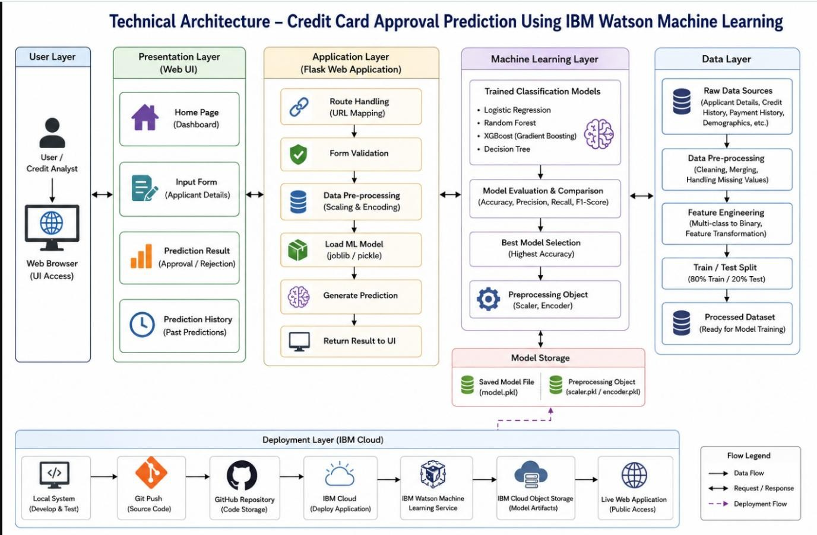

Project Modules Module 1: Dataset Collection
The project begins with collecting a historical credit card approval dataset containing applicant information such as gender, income type, annual income, employment duration, education level, payment history, and other financial attributes. This dataset serves as the foundation for training the machine learning models.

Module 2: Data Preprocessing
The collected dataset is cleaned and transformed before model training. Missing values and duplicate records are removed, categorical features are encoded into numerical values, and payment status is converted into binary labels. These preprocessing steps improve data quality and ensure accurate model training.

Module 3: Exploratory Data Analysis (EDA)
Exploratory Data Analysis is performed to understand the characteristics of the dataset and identify relationships between different features. Various visualization techniques such as Count Plots, Distribution Plots, and Correlation Analysis are used to analyze applicant data and detect important trends.

Module 4: Machine Learning Model Training
Four classification algorithms are implemented to predict credit card approval:
- Logistic Regression
- Decision Tree Classifier
- Random Forest Classifier
- XGBoost Classifier
Each model is trained using the preprocessed dataset to learn patterns from historical credit approval decisions.

Module 5: Model Evaluation
The trained models are evaluated using Accuracy Score, Confusion Matrix, and Classification Report. Based on the evaluation results, the model with the highest prediction accuracy and overall performance is selected and saved for deployment.

Module 6: Flask Web Application
The selected machine learning model is integrated into a Flask-based web application. Users can enter applicant details through an interactive web form, and the system validates the input, preprocesses the data, loads the trained model, and displays an instant prediction indicating whether the application is approved or rejected.

Module 7: Cloud Deployment
The final application is deployed using IBM Watson Machine Learning on IBM Cloud. This deployment allows the model to provide secure, scalable, and real-time credit card approval predictions through a web-based interface, making the application accessible from anywhere with an internet connection.

5. PROJECT PLANNING & SCHEDULING
Phase Activity
Phase 1 Requirement Analysis

Phase Activity
Phase 2 Dataset Collection
Phase 3 Data Cleaning & Preprocessing
Phase 4 Data Visualization
Phase 5 Model Training
Phase 6 Model Evaluation
Phase 7 Flask Web Application Development
Phase 8 IBM Cloud Deployment
Phase 9 Testing
Phase 10 Final Documentation

6. FUNCTIONAL AND PERFORMANCE TESTING
Functional Testing

Test Case Expected Result Status
Open Home Page Home page loads successfully Passed
Enter Applicant Details User inputs accepted Passed
Submit Prediction Prediction generated Passed
Display Result Approval/Rejection displayed Passed
Invalid Input Validation message shown Passed

Performance Testing
- Prediction response generated within a few seconds.
- Flask application handled user requests efficiently.
- Model accuracy compared across multiple algorithms.
- Stable performance during repeated testing.

7. RESULTS
The project successfully predicts whether a credit card application is approved or rejected using machine learning.

Major achievements include:
- Successful preprocessing of applicant data.
- Effective feature engineering.
- Training of four classification models.
- Selection of the best-performing model.
- Successful integration with Flask.
- Real-time prediction through an interactive web application.
- IBM Watson deployment support for cloud-based access.
The application provides quick and accurate predictions that assist financial institutions in reducing manual effort and improving decision-making efficiency.

8. ADVANTAGES & DISADVANTAGES Advantages
- Reduces manual verification effort.
- Faster credit approval decisions.
- Improves consistency in predictions.
- Supports real-time decision making.
- User-friendly web interface.
- Scalable cloud deployment.
- Helps identify high-risk applicants.
- Enhances operational efficiency.

Disadvantages
- Prediction accuracy depends on dataset quality.
- Limited by available training features.
- Cannot replace final human verification in critical cases.
- Requires periodic retraining with updated banking data.
- Performance may vary with unseen applicant profiles.

9. CONCLUSION
The Credit Card Approval Prediction System demonstrates how machine learning can automate financial decision-making processes. Multiple classification algorithms were implemented and evaluated to identify the most accurate predictive model. The selected model was successfully integrated into a Flask web application, enabling users to obtain instant credit card approval predictions based on applicant information.
The project reduces manual effort, improves processing speed, minimizes human error, and provides a practical solution for banks and financial institutions. It also offers valuable learning experience in data preprocessing, exploratory data analysis, machine learning model development, web application development, and cloud deployment.


10. FUTURE SCOPE
Future improvements can include:
- Integration with live banking databases.
- Deep Learning models for enhanced prediction accuracy.
- Explainable AI (XAI) to provide reasons behind approval or rejection.
- Real-time credit score integration.
- Multi-bank credit approval support.
- Mobile application development.
- API integration with banking systems.
- Continuous model retraining using new customer data.
- Advanced fraud detection mechanisms.
- Enhanced security using authentication and encryption.

11. APPENDIX

Technologies Used
- Python
- Flask
- NumPy
- Pandas
- Matplotlib
- Seaborn
- Scikit-learn
- XGBoost
- Joblib
- IBM Watson Machine Learning

Machine Learning Algorithms

- Logistic Regression
- Decision Tree Classifier
- Random Forest Classifier
- XGBoost Classifier

Evaluation Metrics
- Accuracy Score
- Confusion Matrix
- Classification Report

Input Features

- Gender
- Income Type
- Annual Income
- Employment Duration
- Education Level
- Credit History
- Existing Loan Status
- Payment Status
- Other Financial Information
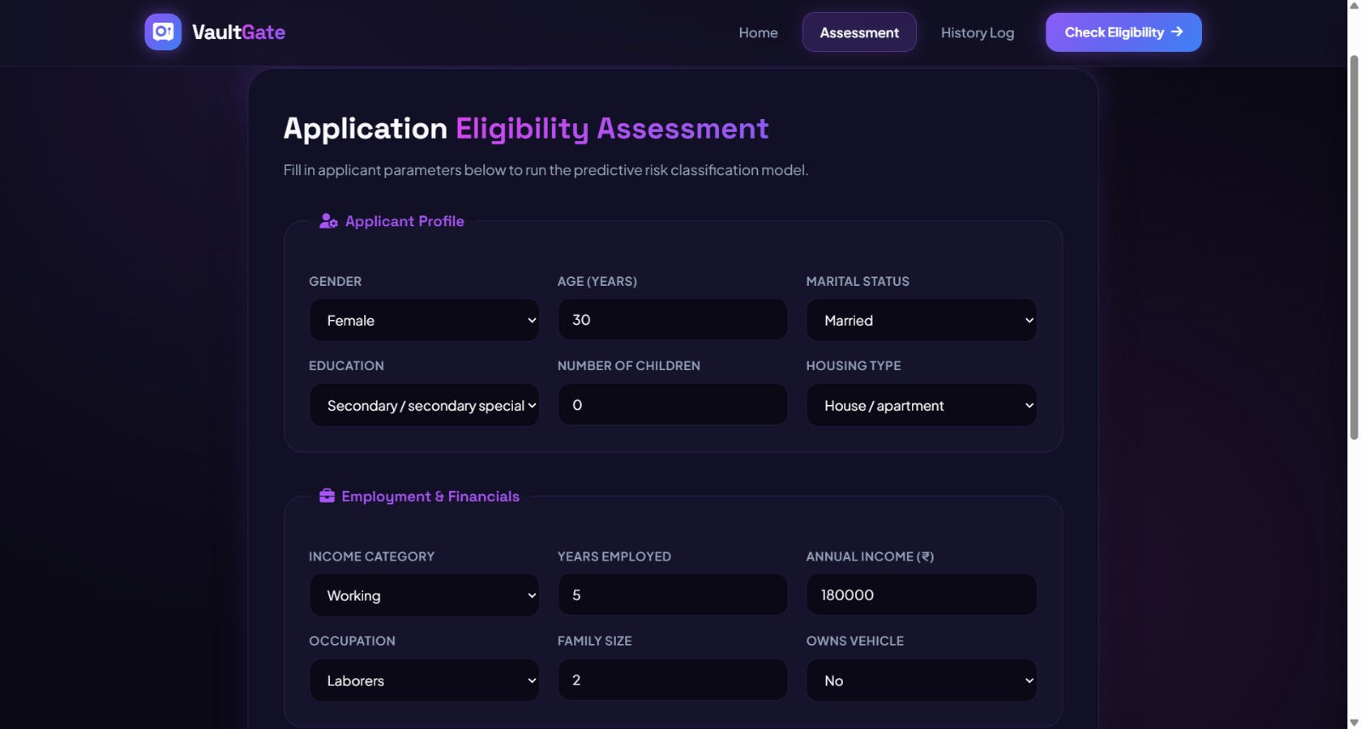

Output

- Credit Card Approved
- Credit Card Rejected
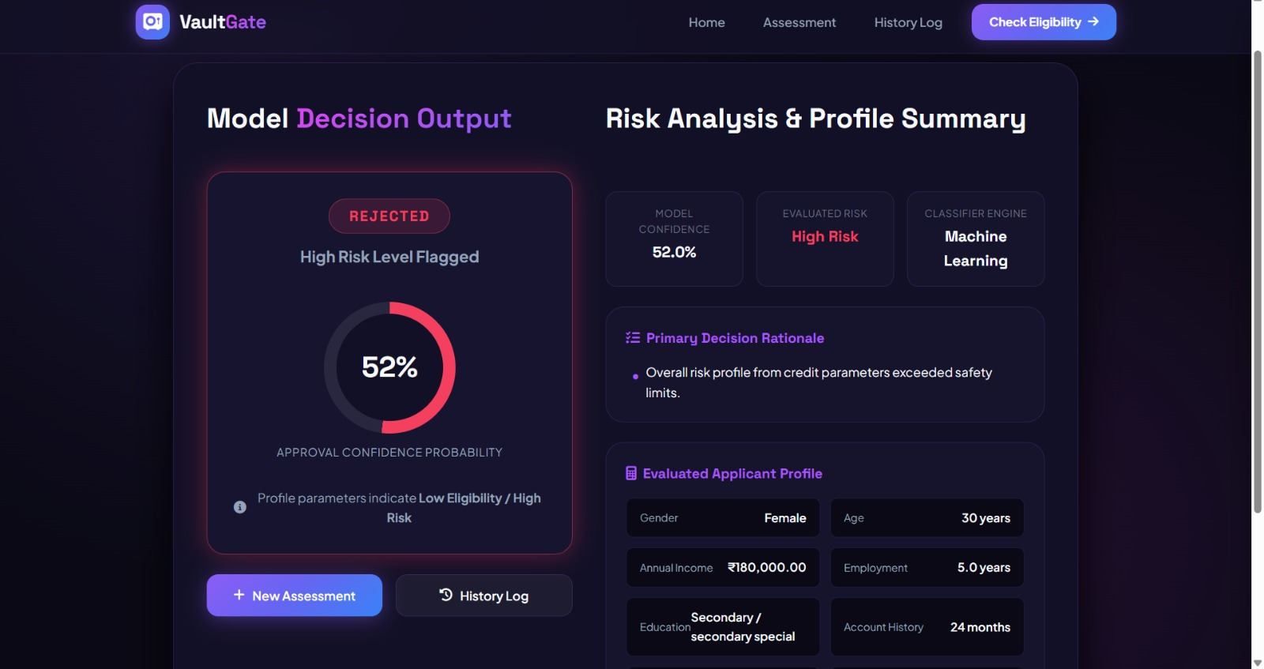
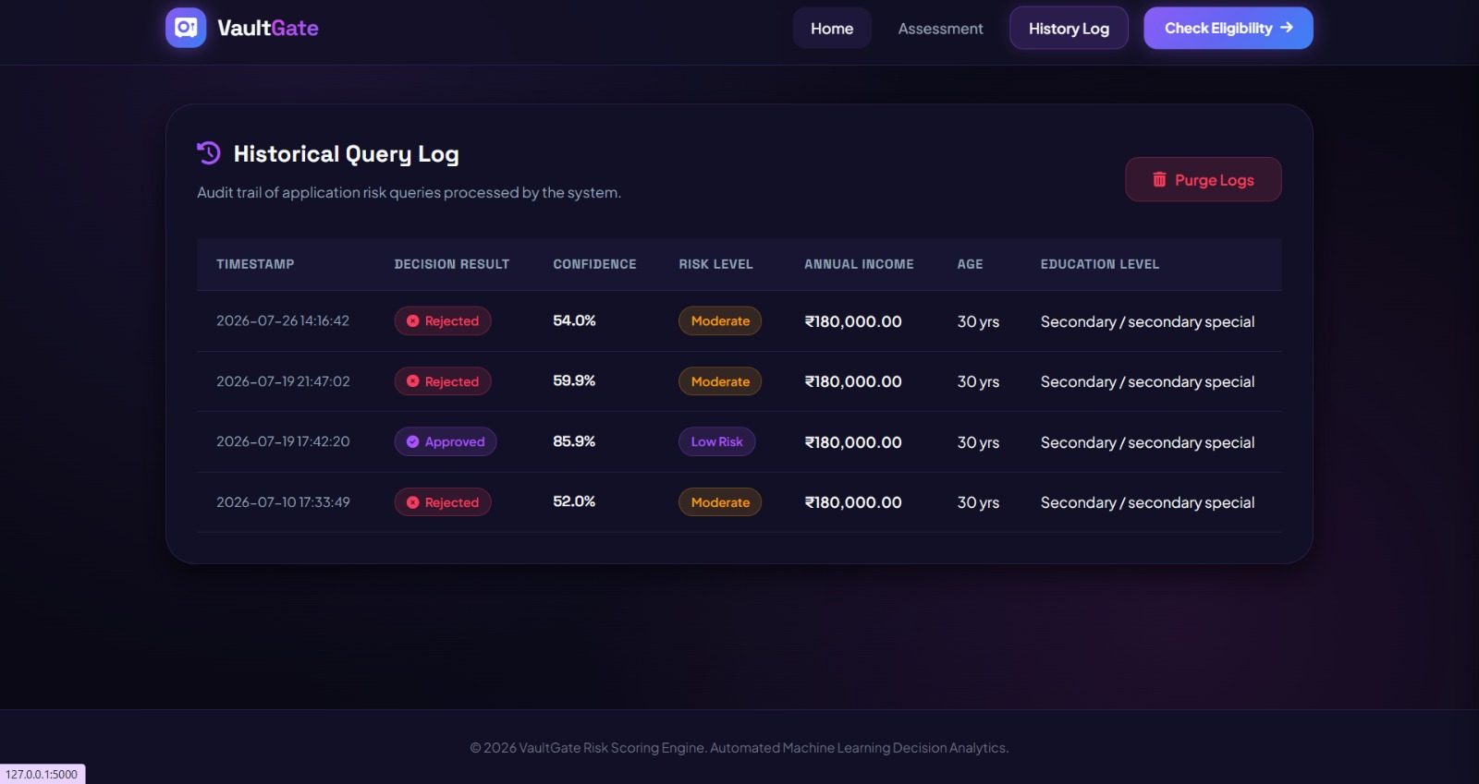

Applications
- Banking Sector
- Financial Institutions
- Loan Processing
- Credit Risk Assessment
- Customer Eligibility Verification
Github link:
https://github.com/vineshvalluri26-hue/credit-card-approval
Demo link:
https://drive.google.com/file/d/1v3ERhgIVMn3oubfpqaDLDPE3wizh2LBy/view?usp=sharing

